Gratitude Group Steering Committee Date: Wednesday, July 5, 2023
Present: Cawth, John Mc, John DP, Sandy P, Brian F, Dan F, Bob R (Jersey), Jim
Discussion based on the topics listed:
- Steering Committee Positions
- District 18 Update
- Intergroup AA update
- Finance update
- Status of face-to-face meetings
- Status of on-line zoom meetings
- Covid Policy, Safety & Security
- Concerns
- Events hosted by GG
- Events hosted by other Organizations.

- Steering Committee Positions.
Currently all positions are filled. Reports were made from the Chair, District 18 Alternate Representative, and the Intergroup Representative.
- District 18 Update. The Group Service Alternate Representative, John DP, describe current district activities. The District is also looking for volunteers for an information booth at State Fair – contact Kathy Jo if interested.
District 18 meetings meet the second Thursday of every month at 630. Zoom ID is 83457117037
  - District 18 Home page: https://district18mpls.org/
  - Area 36 Calendar https://area36.org/events
- Intergroup Update. https://aaminneapolis.org/. Cawth has been our Minneapolis Intergroup Representative. Cawth reported that their finances are down somewhat but not worrisome. Fiscal year ends in September. Intergroup will be holding an Open House this summer. Cawth reports that her two year term is coming up soon. Jim, who is currently a phone volunteer at Intergroup, volunteered to succeed her.
Intergroup publishes a monthly newsletter, the MIRRUS, which includes an article on the step for that month. Intergroup also has an internet directory of all meetings in the greater Minneapolis area https://aaminneapolis.org/meetings/
- Financial Update – April is currently unavailable. An email will be sent out shortly summarizing our Financial Resources
  - Checking Account Balance as of June 30 is approximately $6600. Prudent Reserve is approximately $3000. Total cash assets about $9600
  - Decision on contributions: We decided to restart our monthly contributions to GSO, D18, Area 36 and Minneapolis Intergroup. Monthly contributions would be $200 distributed 80, 40, 40, 40 dollars respectively.

- Status of Face to Face Meetings.
There are currently 13 in-person AA meetings.
There is a noon meeting for every day of the week. Noon meetings have steady attendance. We seem to be more newcomers. New trusted servant for Thursday 12 noon – welcome Doug!
Meeting attendance in the evening seems to be picking up. There is an in person meeting every evening except for Thursday.
There is a CODA meeting on Mondays at 730pm.

The SLA meeting has disbanded due to low attendance. They will merge with a group in St. Paul.
Day | Time | Trusted Servant
Monday | 12 noon | Cynthia
Monday (WOMEN’S) | 6 pm | Ashley
Tuesday | 12 noon | Doug
Tuesday (MEN’S) | 7 pm | James K
Wednesday | 12 noon | Brian F
Wednesday | 8 pm | Eric
Thursday | 12 noon | John DP
Friday | 12 noon | Sandy
Friday (BIG BOOK) | 7 pm | Dwaine
Saturday | 12 noon | Evelyn
Saturday | 8 pm | Dan H
Sunday | 12 noon | John Mc
Sunday | 6 pm | Jason

- Zoom Meetings.
- Noon meetings: Attendance has been steady. A typical meeting is running 10-15 attendees. Mike T to take Saturday Noon Zoom. Sara D took over Wednesday noon. Kari took over Monday noon.
- 8pm meetings: Attendance has been steady for most nights, but growing for some nights. Shaun took over Tuesday night step meeting. Mark Z took over Wednesday night.
- Women’s meetings: Dana is the Monday Women’s Trusted Servant
- Living Sober meeting: no new information
- Step Workbook Study Group: Time changed to Saturday 1100AM
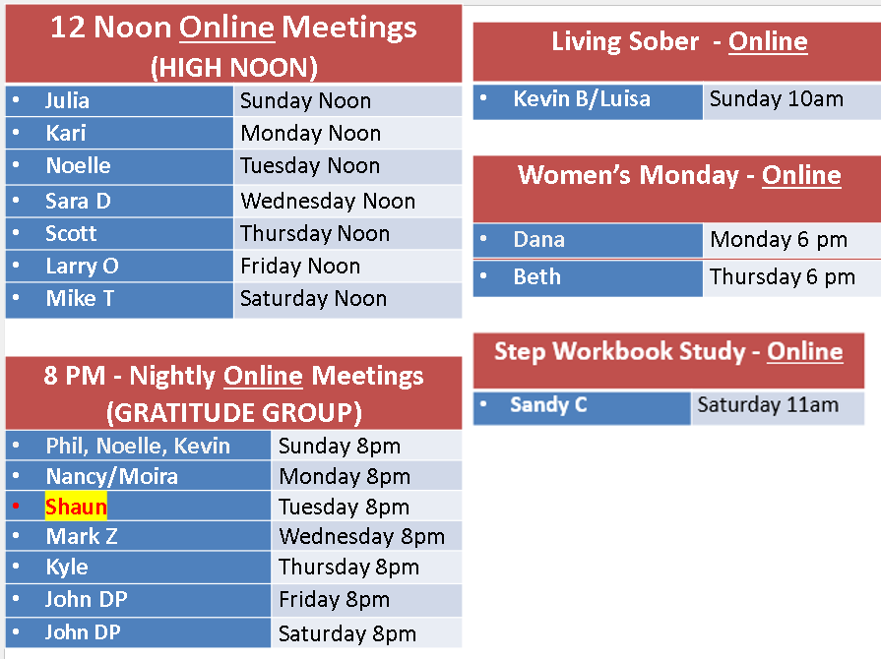
- Covid Policy, Safety and Security. Group voted to move the lockbox to a more secure location. Tuesday the door was found unlocked for the noon meeting. Trusted Servants and Sponsors are encouraged to check that the facility is secure when leaving the building.

- Concerns & Improvements

- Donation of Chairs. Pending – waiting for a report from Dwaine.
- Restock books and pamphlet. Someone will attend the Intergroup Open House to purchase Pamphlets on Sponsorship and copies of As Bill Sees It.
- Revising Bylaws. The Committee amended and approved the proposed bylaws dated July 5, 2023. Bylaws will be reviewed periodically to ensure their functionality.
- Cross talk. There was a discussion around the definition of crosstalk and how to minimize it. Trusted Servants will be encouraged to remind members that advice giving, interruptions, and comments can create problems. One useful definition of Crosstalk is available in the Clubhouse Operating Guide.
- Sobriety Medallions. The question arose regarding a member who request an AA medallion, who is still using other medications (such as cannabis). The consensus of the committee is that we do not take opinions on outside issues. We are about quitting drinking. Any member who uses other medications who asks if they are deserving of a medallion should be advised to check with their sponsor about selecting a sobriety date. Otherwise, we will leave the decision up to the group conscious of that meeting.
- Events hosted by Gratitude Group
- Not applicable
- Events hosted by other Groups and Service Organizations – see attached flyers. See the Minneapolis Intergroup website: https://aaminneapolis.org/events/
Recorded by John Mc, Secretary.

